Smart Office Assistant powered by Watson Assistant

Domain: Artificial Intelligence

### **Abstract:**

The objective of this project is to build an office assistant, which will manage the employee related or management related issues.

### **Tool : Watson Assistant**

Watson Assistant is IBM’s AI product that builds, trains, and deploys conversational interactions into any application, device or channel. Watson Assistant can be deployed in any cloud or on-premises environment – meaning smarter AI is finally available wherever you need it.

### **Steps to Design Smart office assistance chat bot:**

1. Login to smart intern

**Create assistant:**

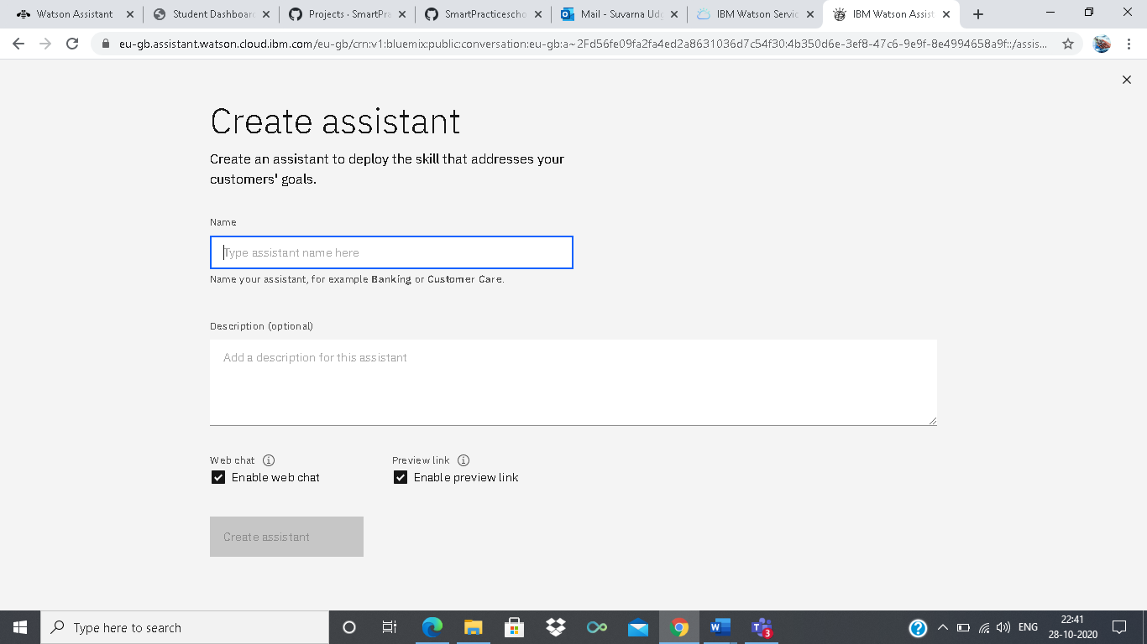

## Intent:

A intent reflects the objective or purpose of a sentence

**Create intents:**

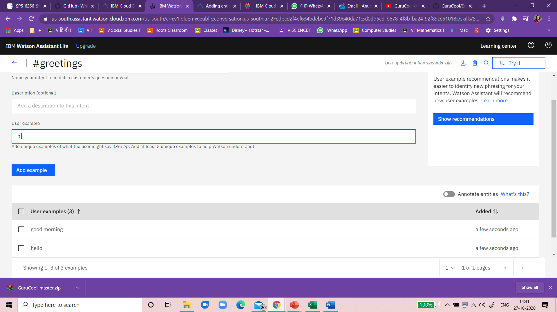

Create Entities:

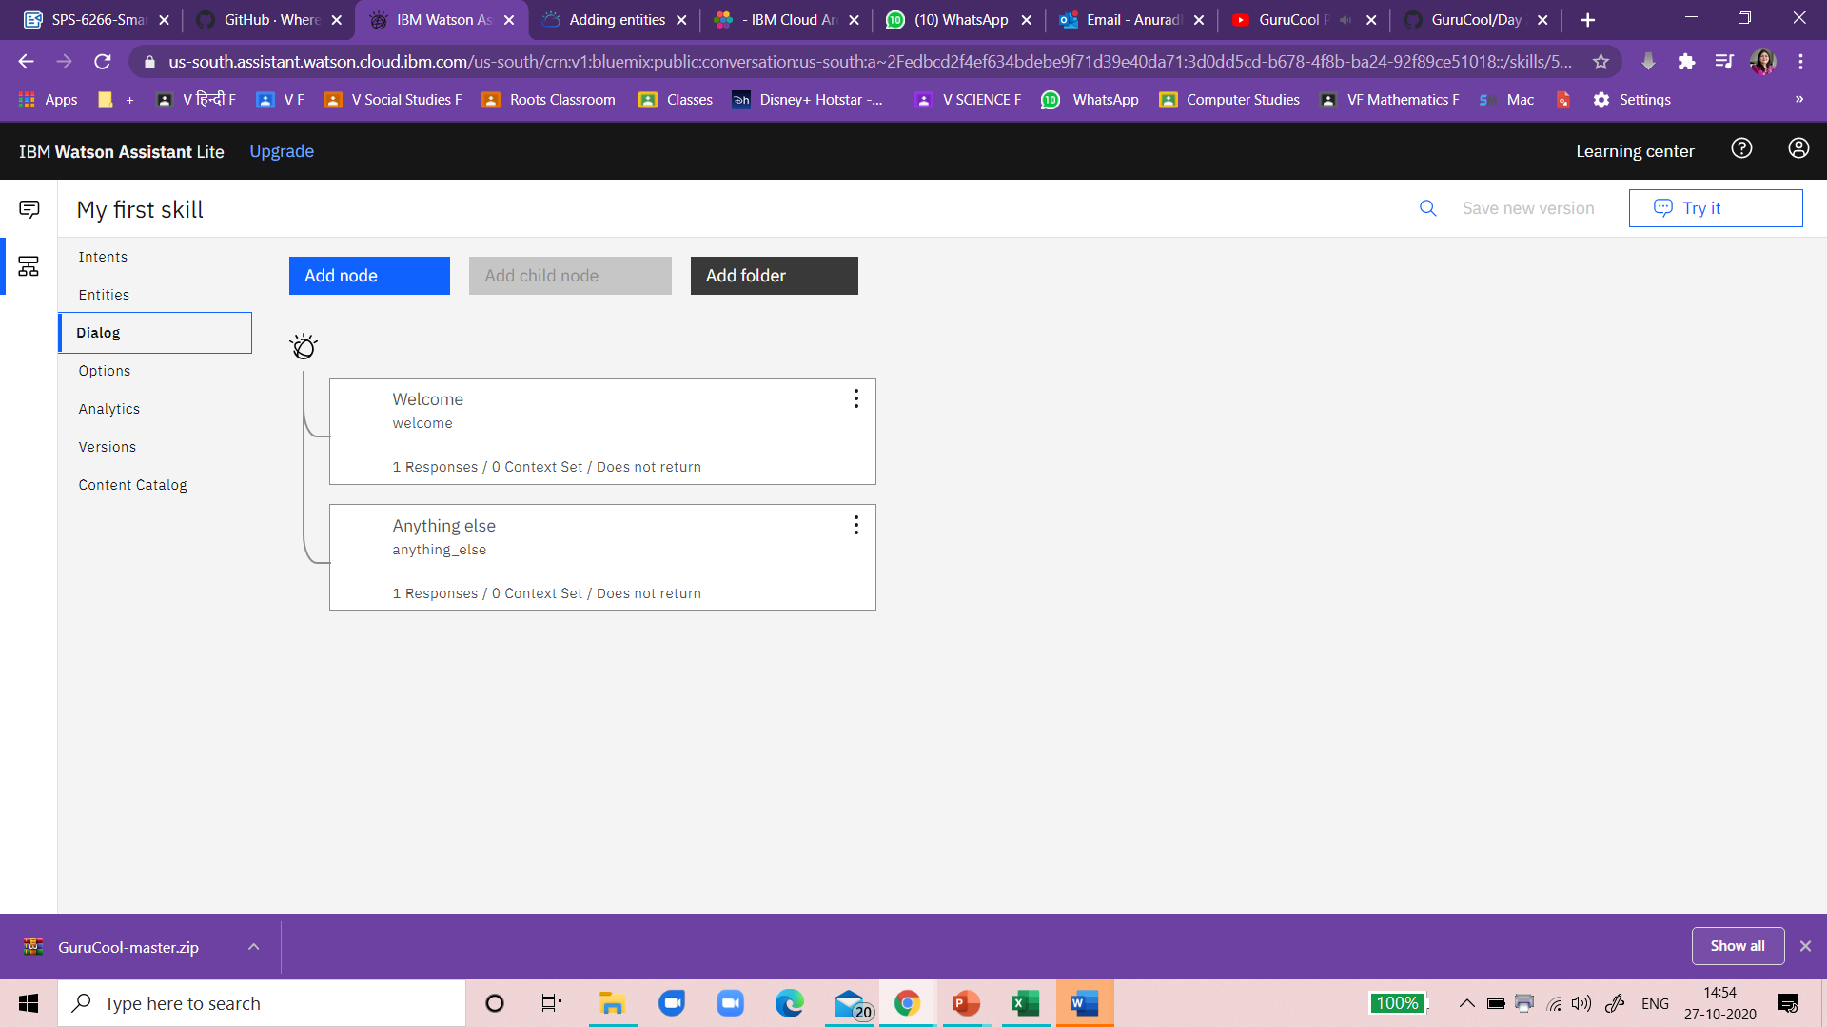

Add assistant Response

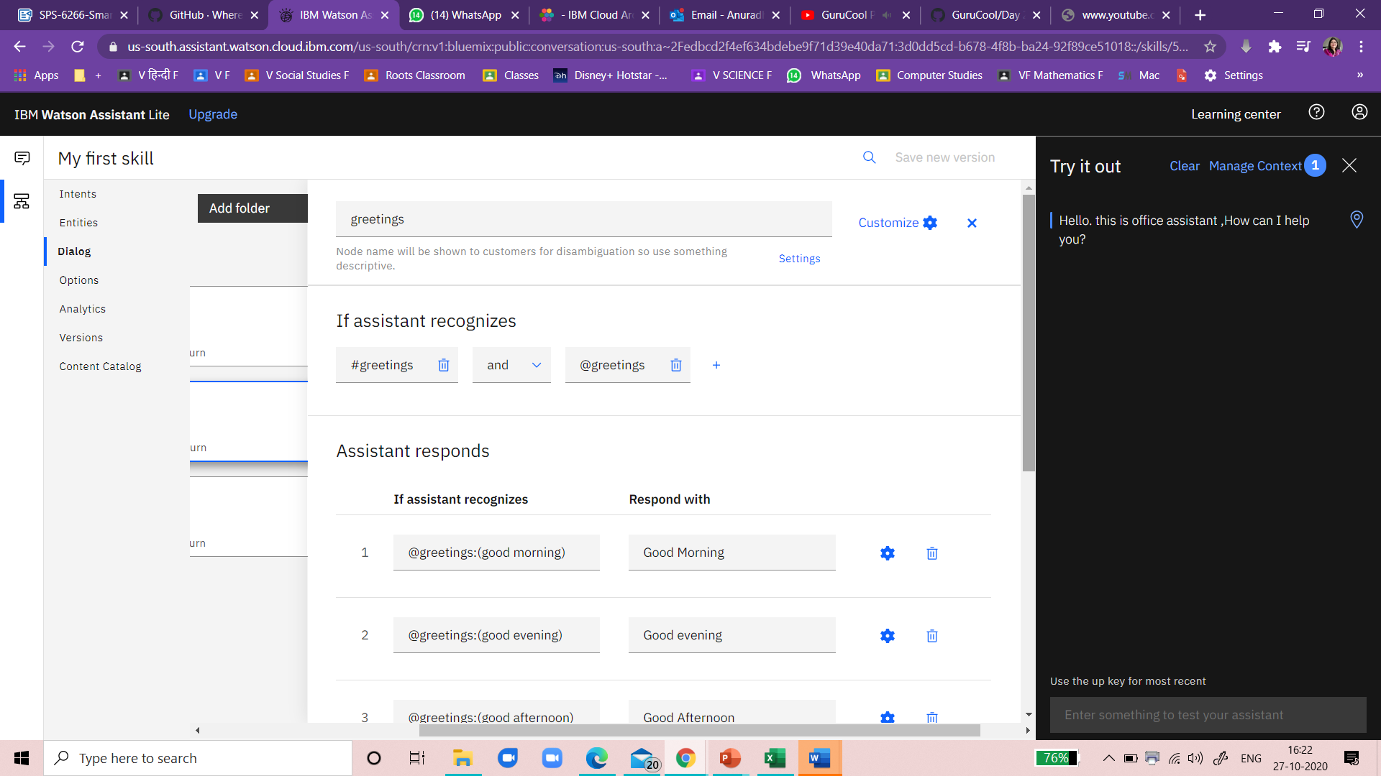

### **Chatbot URL :**

<https://web-chat.global.assistant.watson.cloud.ibm.com/preview.html?region=eu-gb&integrationID=de465338-5571-4831-a176-08bad194de40&serviceInstanceID=4b350d6e-3ef8-47c6-9e9f-8e4994658a9f>

Screenshots of Project

